Ambidextrous Organizations

Ambidextrous organizations establish project teams that are structurally independent units, each having its own processes, structures, and cultures, but are integrated into the existing management hierarchy.

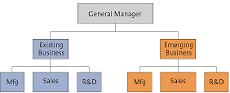

“We discovered that some companies have been quite successful at both exploiting the present and exploring the future, and as we looked more deeply at them we found that they share important characteristics. In particular, they separate their new, exploratory units from their traditional, exploitative ones, allowing for different processes, structures, and cultures; at the same time, they maintain tight links across units at the senior executive level. In other words, they manage organizational separation through a tightly integrated senior team. We call these kinds of companies “ambidextrous organizations,” and we believe they provide a practical and proven model for forward-looking executives seeking to pioneer radical or disruptive innovations while pursuing incremental gains. A business does not have to escape its past, these cases show, to renew itself for the future.”

The Ambidextrous Organization (HBR) - Charles A. O’Reilly III, Michael L. Tushman
https://hbr.org/2004/04/the-ambidextrous-organization

Crowdocracy

Crowdocracy is a system for self-government that enables a community of people to replace democratic principles by the wisdom of the crowd.

The essence of the structure of crowdocracy is as follows:

The crowd becomes the legislature with the power to propose and draft policy and make all policy decisions. Similar to the communities behind Wikipedia and Linux, in a crowdocracy, the community writes its own rules.

The executive officers get appointed by the crowd and execute that policy within the delegated authority of the crowd. In other words, managers are truly servants in the sense that they only do what the crowd allows them to.

The independent judiciary adjudicate and act as the guardians of the crowdocratic process. This means that a small number of independent coaches or referees watch over the processes and make sure that people follow them.

Organizational design in a crowdocracy is emergent. The creation of units, divisions or institutions is a purely bottom-up process and depends on the decisions of the crowd.

Crowdocracy: The Future of Government & Governance - Alan Watkins, Iman Stratenus
https://www.amazon.com/Crowdocracy-Future-Government-Governance-Wicked/dp/1910692158

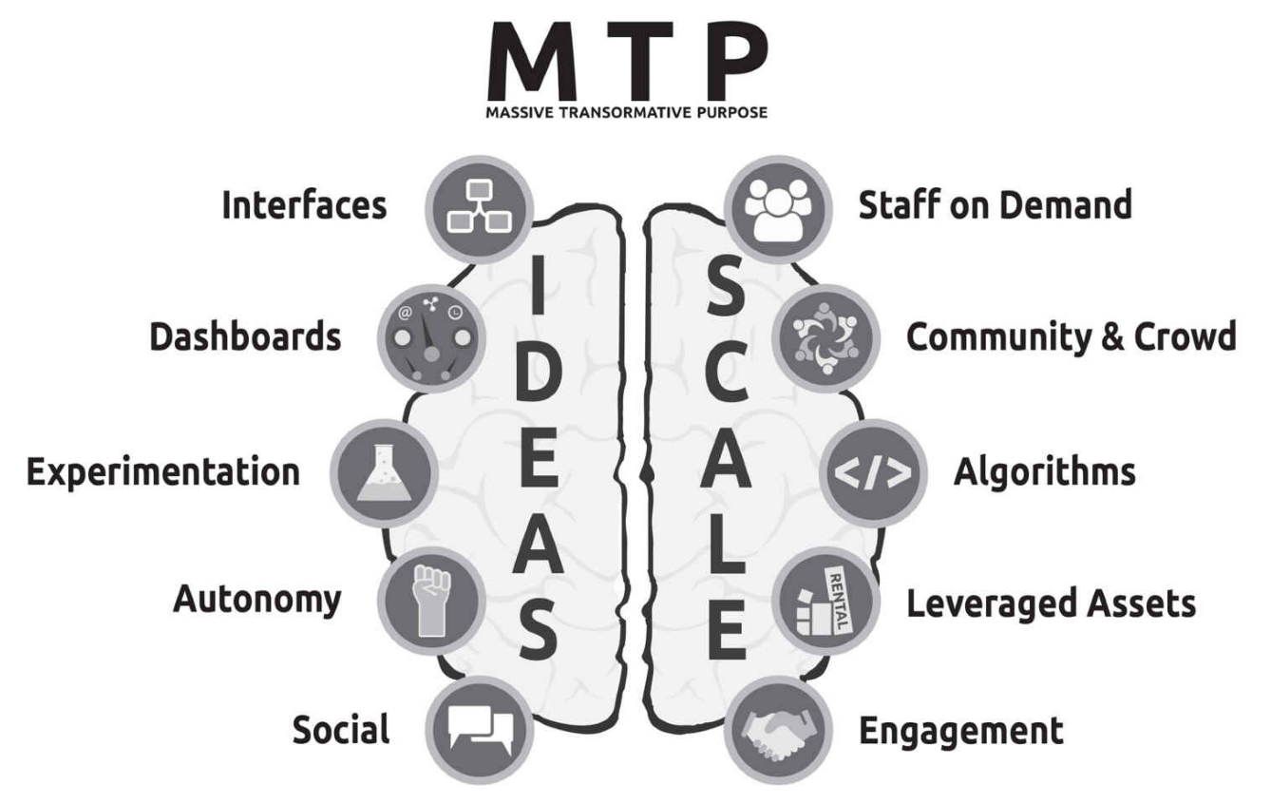
Exponential Organizations

An Exponential Organization (ExO) is one that has a great potential to scale. Some great examples are: Airbnb, GitHub, Google, Netflix, Quirky, Tesla, Uber, Waze, Valve, Xiaomi.

This is achieved by implementing as many as possible of the following requirements:

MTP: The organization has a Massive Transformative Purpose that inspires and attracts employees, customers and other stakeholders.
Staff on Demand: Leveraging workers outside the base organization is key to speed, functionality and flexibility in a fast-changing world.
Community & Crowd: The ExO leverages people outside the core organization for idea generation, funding, design, distribution, marketing and sales.
Algorithms: Using algorithms, as part of the business model, is much more objective, scalable and flexible than working with human beings.
Leveraged Assets: When assets are rare or scarce, ownership is best. But when assets are information-based or commoditized, accessing is better than possessing.
Engagement: Engagement is a key element for scaling the organization into the community and crowd and for creating external network effects.
Interfaces: Interfaces are filtering and matching processes by which ExOs bridge externalities to internal control frameworks.
Dashboards: ExOs need real-time, adaptable dashboards with all essential company and employee metrics, accessible to everyone in the organization.
Experimentation: Large numbers of bottom-up ideas, properly filtered, always trump top-down thinking, no matter the industry or organization.
Autonomy: When dealing with a rapidly changing environment and the fluid boundaries of business units, more work should be done by crosscutting, self-organizing project teams.
Social Technologies: Social technologies create transparency and connectedness and, most importantly, lower an organization’s information latency.

Exponential Organizations: Why new organizations are ten times better, faster, and cheaper than yours (and what to do about it) - Salim Ismail, Michael S. Malone, Yuri van Geest

Holacracy

Holacracy is a way of running an organization that removes power from a management hierarchy and distributes it across clear circles and roles. The work can then be executed autonomously, without micromanagement. There is a clear set of rules, and processes for how a circle (team) breaks up its work and defines roles with clear responsibilities.

With Holacracy, roles are defined around the work, not people, and are updated regularly. People fill several roles in various circles. Authority is truly distributed to circles and roles. Decisions are made locally. The org structure is regularly updated via small iterations. Every circle self-organizes. Everyone is bound by the same rules, CEO included. Rules are visible to all.

Example 1
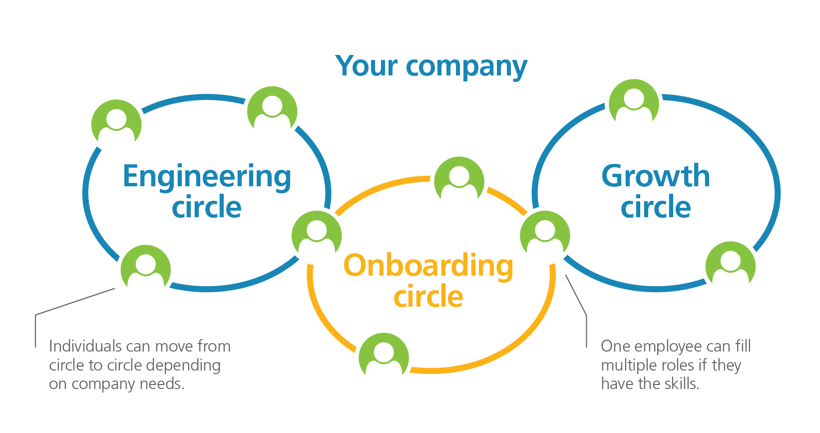
Example 2
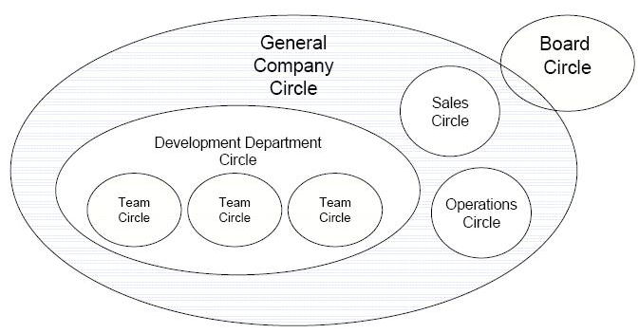

Holacracy: The Revolutionary Management System that Abolishes Hierarchy - Brian Robertson
http://www.holacracy.org/

LeSS - Large-Scale Scrum

LeSS is Scrum scaled up. It applies the principles, elements, and purpose of Scrum in a large-scale context. LeSS tries to add as little extra process and roles as possible - every organization will probably need “more”, but it recognizes that those needs are contextual.

LeSS is designed to work for up to eight teams. In these settings, the following principles apply:
- Roles: one overall Product Owner, two to eight Teams, ScrumMasters
- Artifacts: There is one potentially shippable product increment, one Product Backlog, and a separate Sprint Backlog for each Team
- Events: There is one Sprint for the whole product; it includes all teams and ends in one potentially shippable product increment.
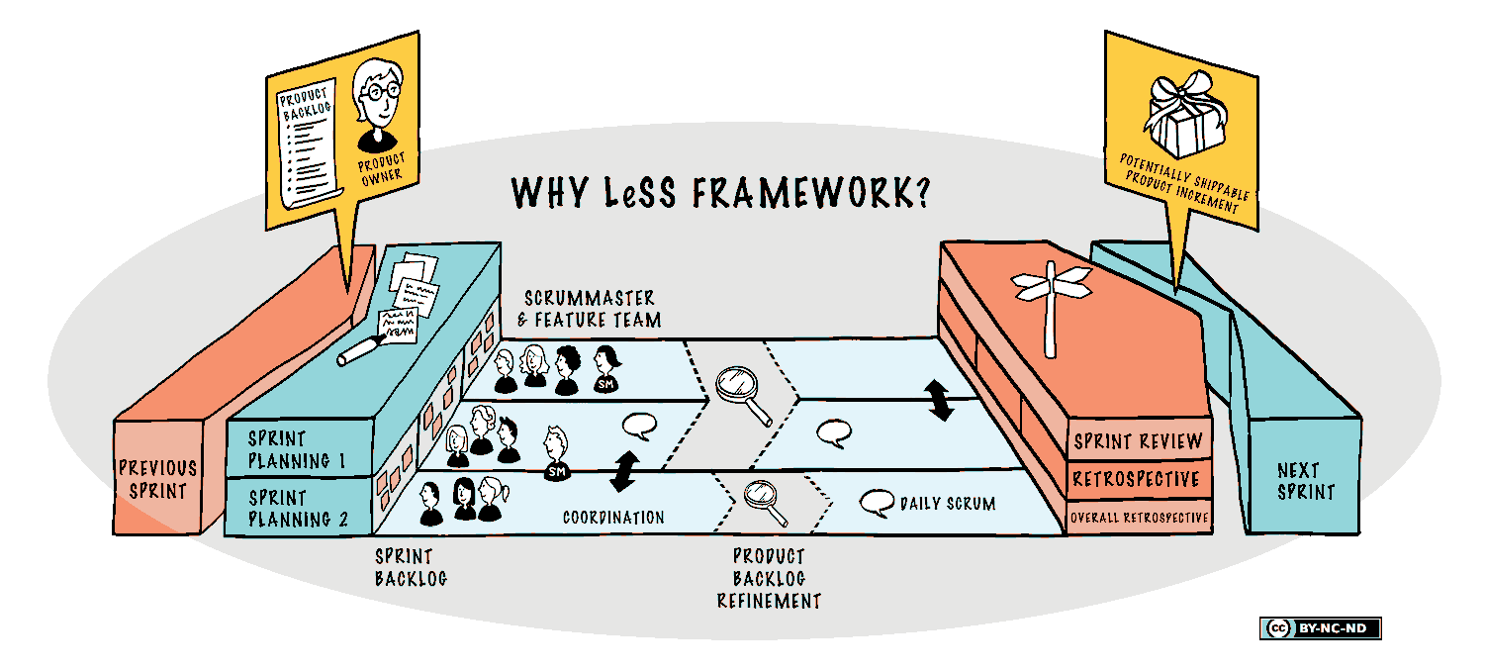
For larger contexts they provide LeSS Huge where a Product is split into several Areas. Each Area follows LeSS and thus each can scale to eight teams. Each Area has an Area PO, and the whole Product group has a single Product Owner.
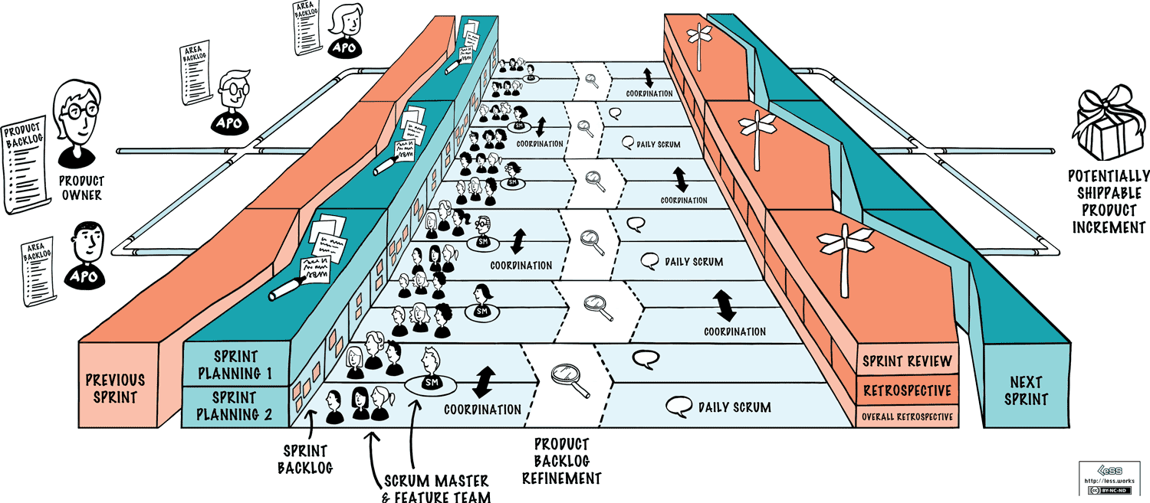
Craig Larman, Bas Vodde
https://less.works/
Liberating Structures

Liberating Structures are adaptable microstructures that make it possible for groups of people of any size to radically improve how they interact and work together.

Importing or imposing best practices usually involves trying to fit a square peg in a round hole. Context, culture, and people do matter more than we like to admit, and resistance inevitably emerges when we discount them.

With Liberating Structures, the focus instead is not on best practices, but on habits: changing and improving behaviors, and patterns of interaction. Changes are not forced by leaders from above but discovered and co-created by frontline people with the support and participation of their leaders.

Simple shifts in routine patterns of interaction make it possible for everyone to be included, engaged, and unleashed in solving problems, driving innovation, and achieving extraordinary outcomes.

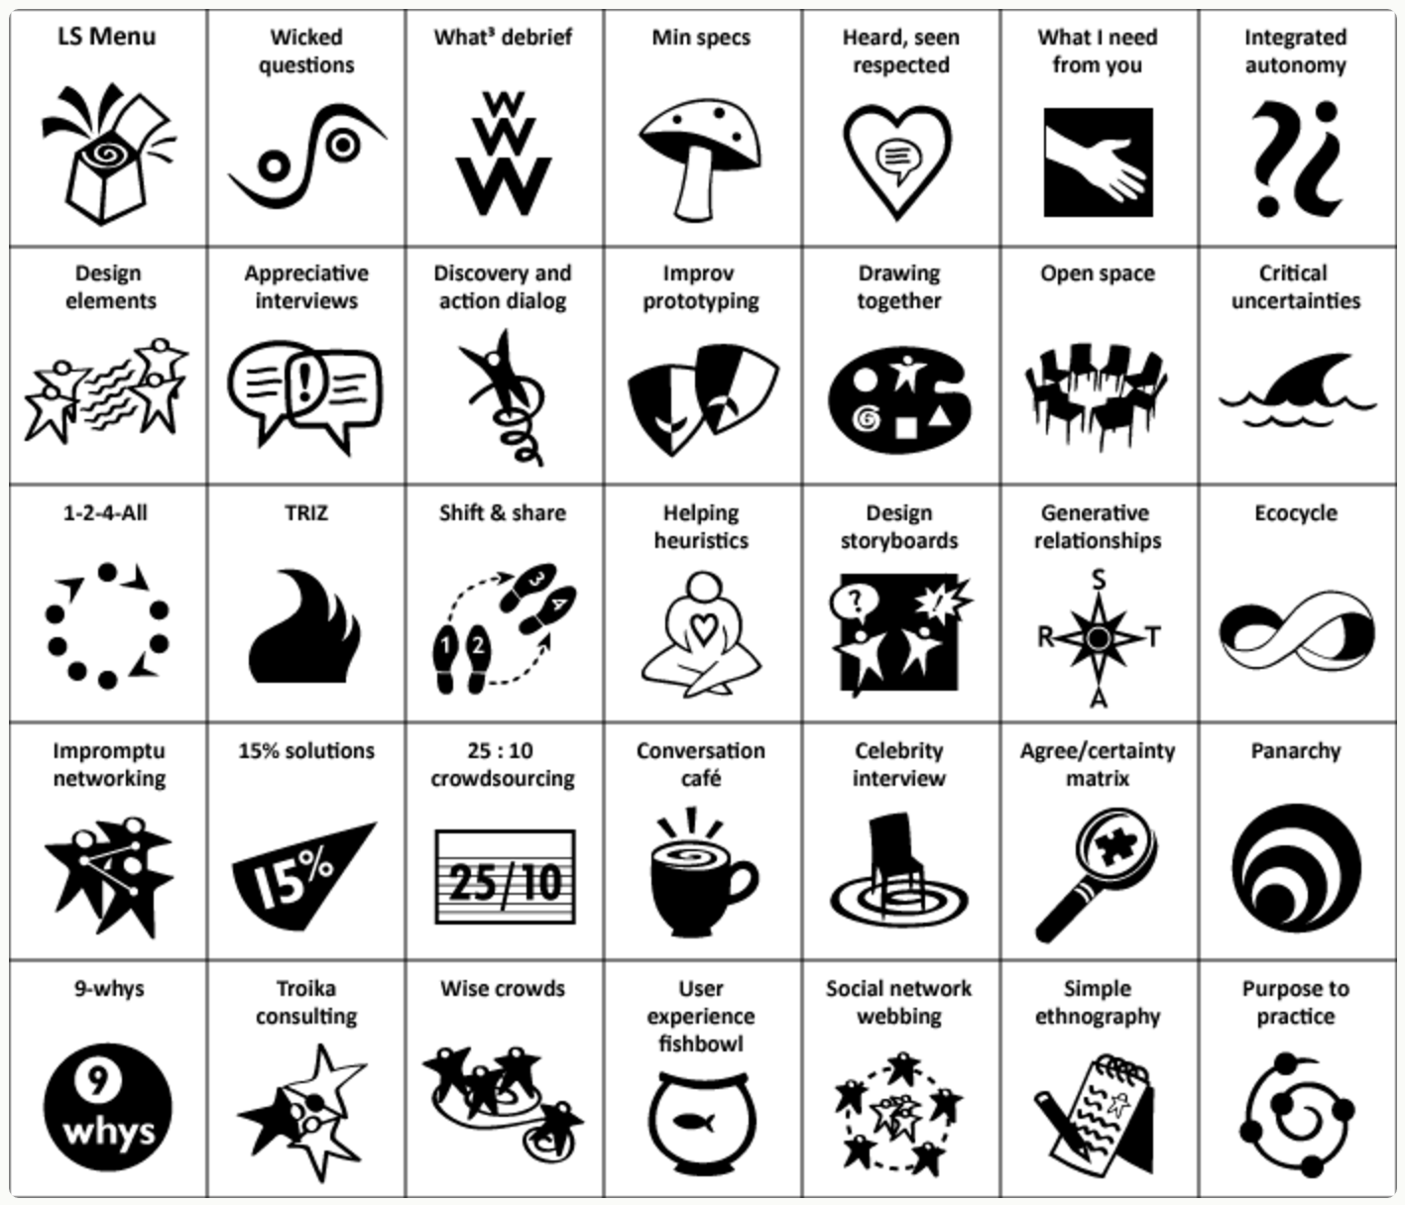

The Surprising Power of Liberating Structures - Henri Lipmanowicz, Keith McCandless
http://www.liberatingstructures.com/

Liquid Organizations

Liquid Organizations tries to replace the rigid structures and hierarchies of most organizations with an adaptive, dynamic and anti-fragile organization that embraces constant change. This is supported by a platform of tools and processes - a software platform is needed but it’s not sufficient.

Liquid Organizations is based on lean management and open collaboration principles.

The 4 pillars for a liquid organization are
- Collaborative working board
One shared Kanban board for the entire organization. Makes the flow visible and explicit to everybody. Only “pull” from people that decide to start what has been collectively approved as “to be started” and then collectively prioritized.
.
- Credits accounting system
There are no job titles or management - instead people are awarded Credit from the activities they contribute to based on the value they bring to that activity. The Credits are converted into money.
- Decision making support
Decisions within an activity are taken by the company members using lazy-majority voting - each person can vote within a timebox (usually 2-5 days) and then votes are counted. Larger decisions has slower, but equally clearly defined, decision processes.
- Reputation tracing
A reputation tracing system captures and visualizes contribution, transparency and value generation from everyone. It shows the trace of healthy behaviours, and let best practices and high level skills emerge. This part of the platform looks much like an enterprise social network - but brings transparency on what works well on all other pillars.

Jacopo Romei and Stelio Verzera, Cocoon Projects
http://liquido.cocoonprojects.com/

Podular Organizations

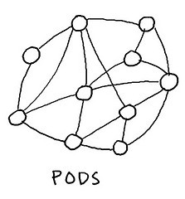
Pods are small, autonomous units enabled and empowered to deliver the things that customers value. A pod can act and react quickly and easily, without fear of disrupting other business activities. Pods focus on value-creating activities rather than support activities.

For a podular system to work, cultural and technical standards are imperative. This means that a pod’s autonomy does not extend to choices in shared standards and protocols. This kind of system needs a strong backbone that clearly articulates those standards and provides a mechanism for evolving them when necessary.

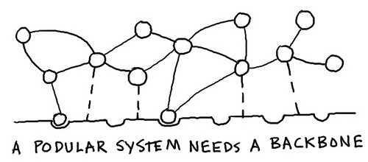

The Connected Company - Dave Gray
The Future is Podular (Medium) - Dave Gray
https://medium.com/the-connected-company/the-future-is-podular-c71d090abf80

Responsive Organizations

Responsive Organizations are designed to thrive in less predictable environments by balancing the following tensions:

Profit <-> Purpose
Today people are looking for organizations that have a purpose broader than just making money. Rather than viewing profit as the primary goal of an organization, progressive leaders see profit as a byproduct of success.

Hierarchies <-> Networks
Technology and connectivity has increased our ability to self-organize, collaborating more easily across internal and external organizational boundaries. It is no longer necessarily true that coordinating through a Manager is more effective than people self-organizing.

Controlling <-> Empowering
Circumstances and markets change rapidly as information flows faster. Now the people with the best insight and decision-making ability are often people closest to the customers.

Planning <-> Experimentation
Because we can't predict the future, time and resources devoted to planning are a less valuable investment than embracing agile methods that encourage experimentation and fuel rapid learning.

Privacy <-> Transparency
In this world of abundant information and connectedness the potential benefits of trusting people who share the organization’s purpose to act on information as they see fit often outweighs the potential risks of open information being used in counter-productive ways.

http://www.responsive.org/manifesto/

SAFe - Scaled Agile Framework
SAFe is a comprehensive framework that provides guidance for how to scale agile to large contexts on the portfolio, program and team level. It continues to evolve - see below for a picture of SAFe 4.0.

The primary construct of SAFe is the Agile Release Train (ART) which is a self-organizing group of Agile teams (5-12 teams) that plans, commits and executes together. The ART has a single vision, roadmap and product backlog. Program Increments (PIs) provides a development timebox (default 10 weeks) to facilitate planning, synchronization and retrospect. Releases are not necessarily synchronized with the PIs - teams can release at any time.

Dean Leffingwell
http://www.scaledagileframework.com/

Scrum.org Nexus

Nexus is a framework for developing and sustaining scaled product and software development initiatives. It is an exoskeleton that rests on top of multiple Scrum Teams when they are combined to create an Integrated Increment.

On top of three to nine standard Scrum teams, Nexus adds a new role, the Nexus Integration Team, which exists to coordinate, coach, and supervise the application of Nexus. The Nexus Integration Team consists of a Product Owner, a Scrum Master, and Nexus Integration Team Members. The members of the Nexus Integration Team may also work on some of the Scrum Teams.
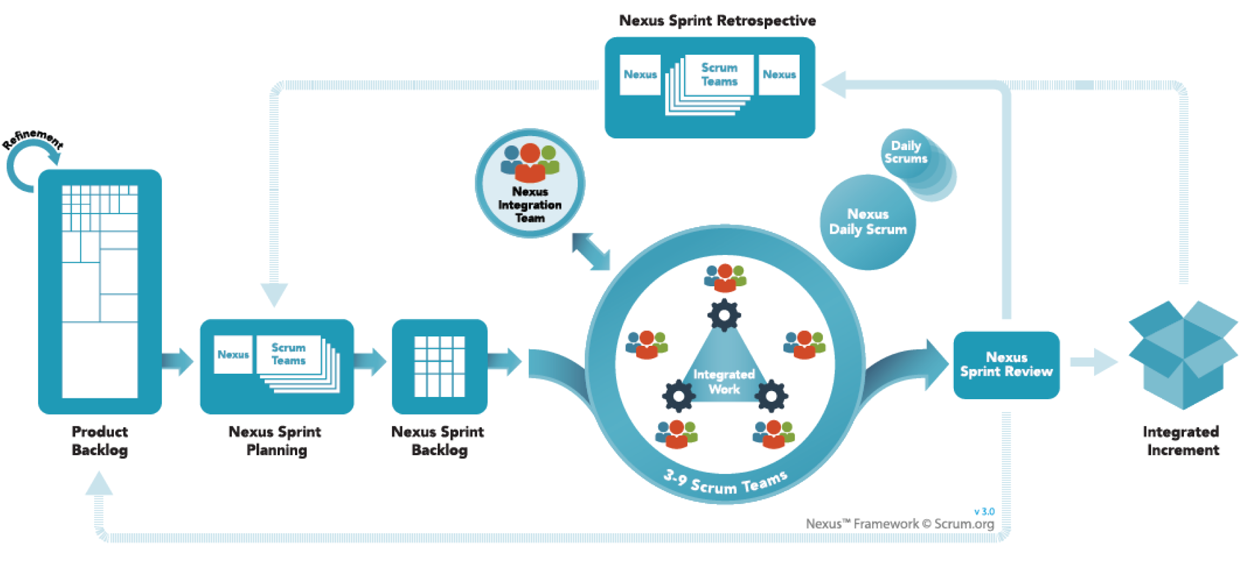
Ken Schwaber
https://www.scrum.org/Resources/The-Nexus-Guide

Self-Management

Morning Star, W.L. Gore, and Nucor are examples of companies with a totally flat organizational structure. They have no managers.

First Principle
People should keep their commitments to others.

Second Principle
People should not use force against others.

Self-management in flat organizations can only work with the following requirements:

No titles: There are no job titles at all in the entire organization.

No command authority: Getting something done requires persuasion, not coercion.

No unilateral authority to fire: People can only be fired by a panel of peers.

Colleagues: Nobody is an employee. Everyone signs agreements with each other.

Coaching and mentoring culture: Coaching capability is part of the whole system.

Accountability process: There is a defined process for conflict resolution.

Freedom: People do what they love doing.

In a self-managed organization, all organizational structures emerge bottom-up and nothing is designed up-front by a manager.

Beyond Empowerment: The Age of Self-Managed Organization - Doug Kirkpatrick
https://www.amazon.com/Beyond-Empowerment-Age-Self-Managed-Organization/dp/0615470149

Sociocracy 3.0
Semi-autonomous, self-organizing and self-governing circles are the basic building blocks of Sociocracy 3.0. It is important to know that people may hold roles in more than one circle. Sociocracy 3.0 meets organizations where they are, and takes them on a journey of continuous improvement. There’s no radical change or reorganization. Sociocracy 3.0 employs The Kanban Method as a change method, and provides a collection of patterns an organization can adopt to become more effective. And Sociocracy 3.0 is fully built on consent-driven decision making.

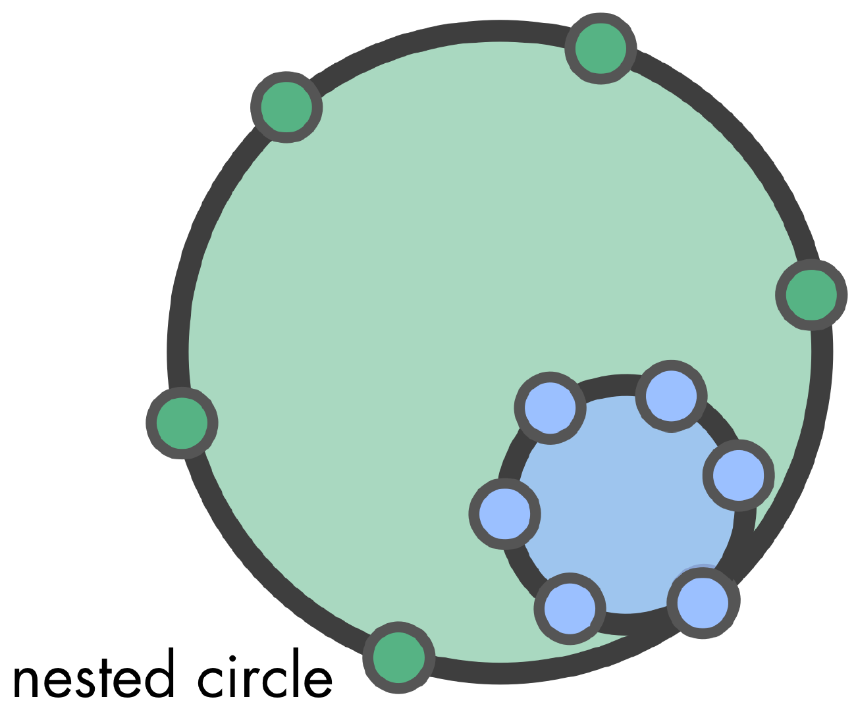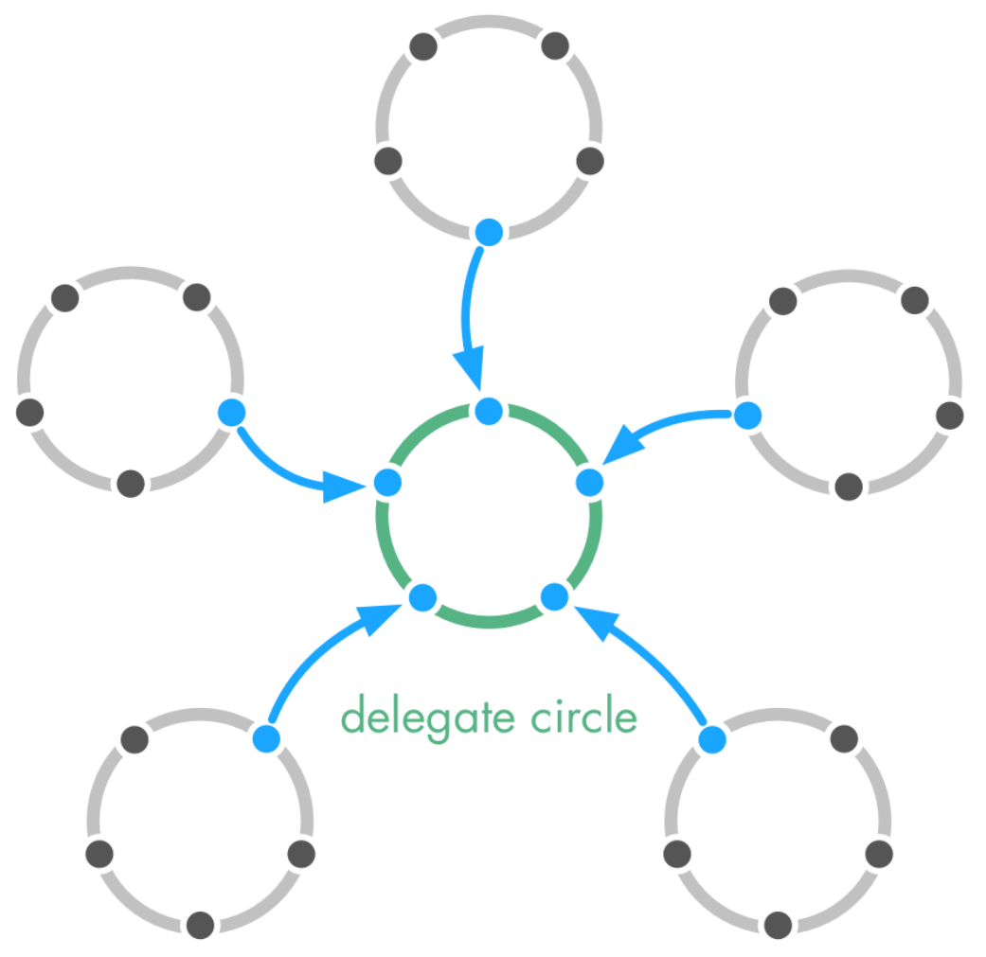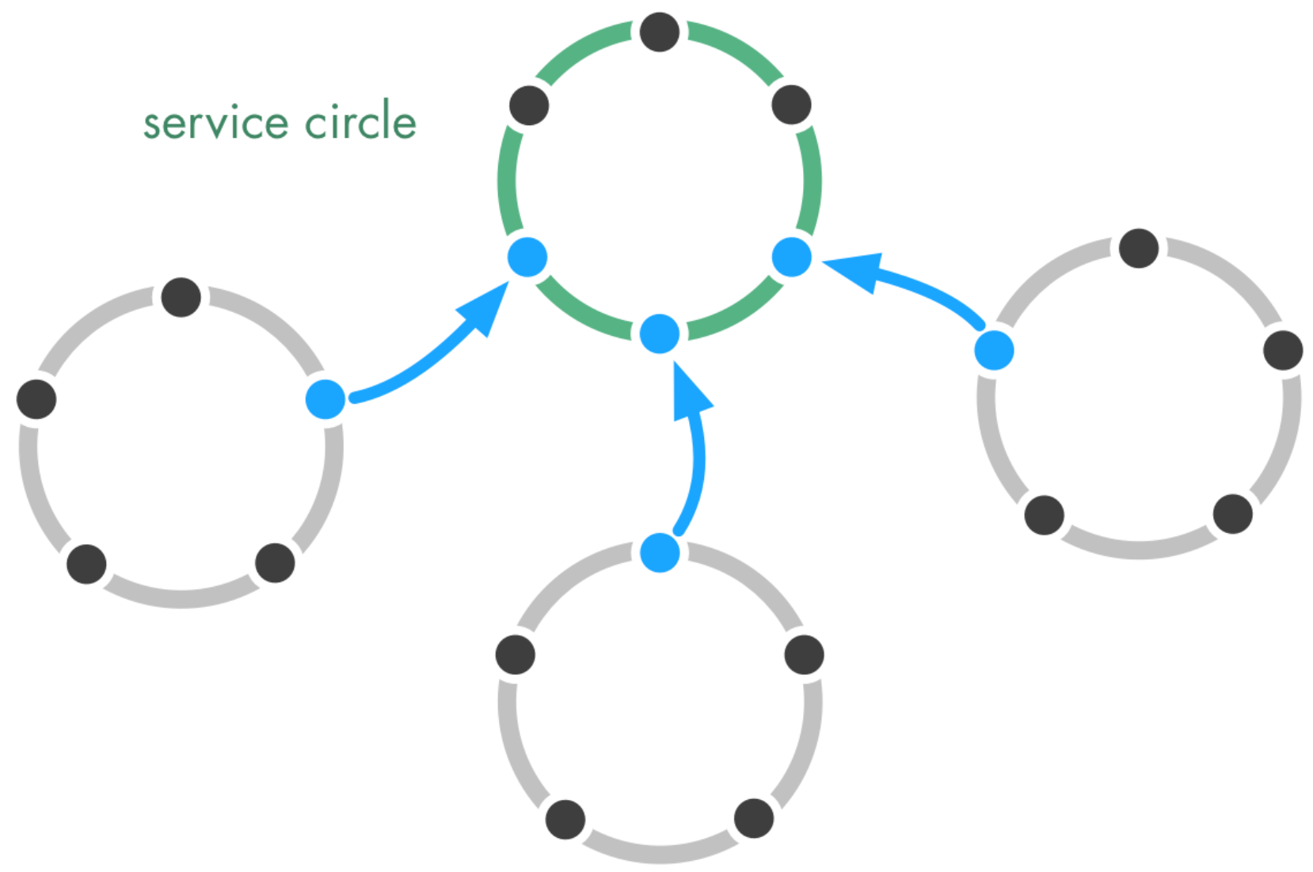
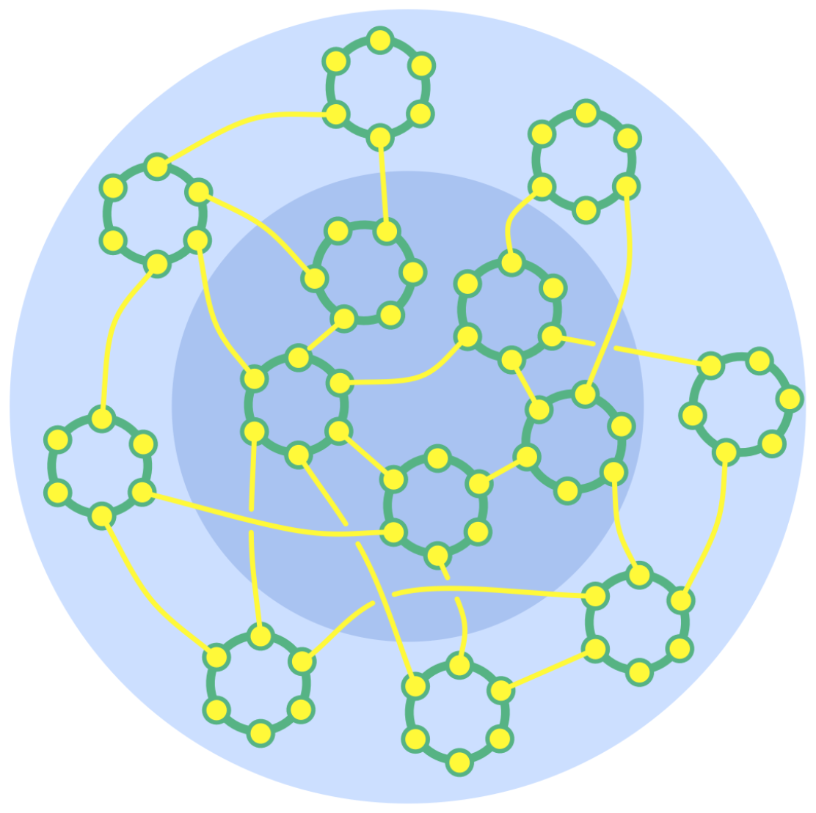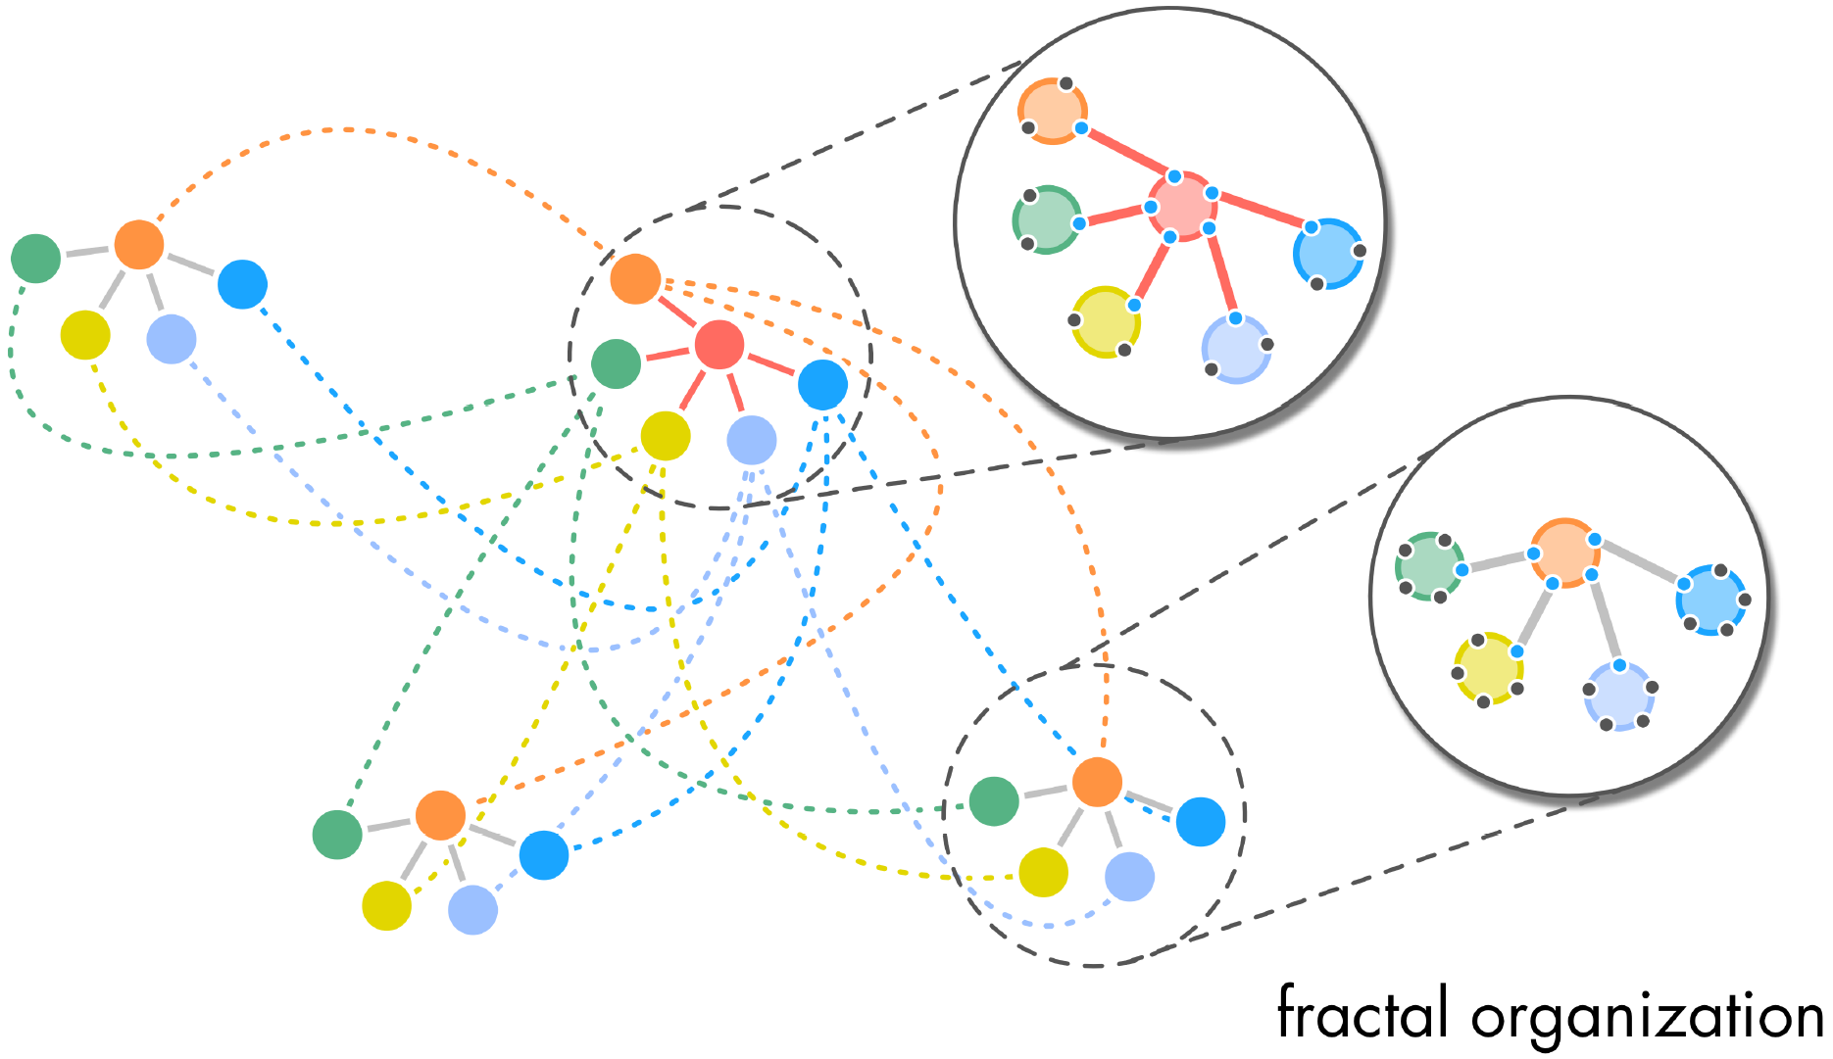
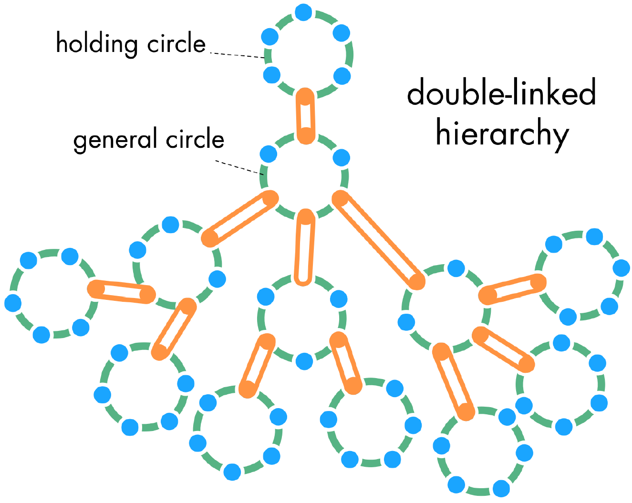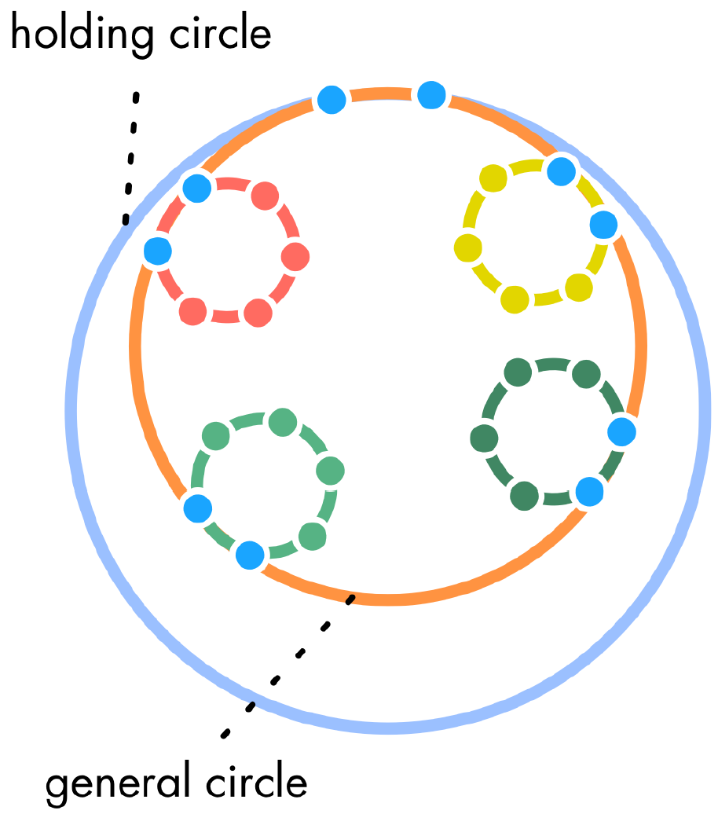

Bernhard Bockelbrink and James Priest
http://sociocracy30.org/

Spotify Model

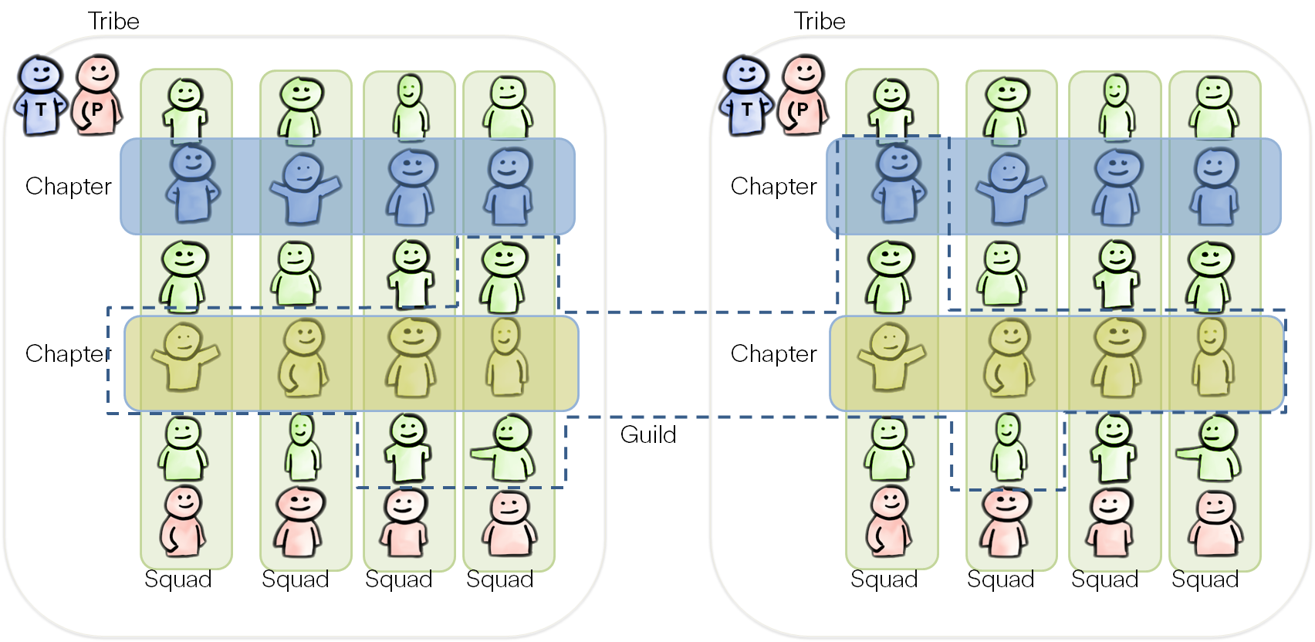

Spotify keeps evolving how they work and organize constantly - but some parts are fairly stable and has become known as The Spotify Model. The model is focused on the autonomous squad - cross-functional agile teams with full end-to-end ownership of their mission. The squad contains everyone needed to deliver on that mission - from idea to production and maintenance. Tribes bring several squads together with similar missions in a larger container.

Chapters is the line function where individuals have their manager that supports their personal growth. Chapters are based on skills - e.g. a mobile chapter brings mobile developers together. Guilds are communities of practice where anyone interested in a certain topic can opt-in to share knowledge and learn from their peers.

Anders Ivarsson, Henrik Kniberg
http://blog.crisp.se/2012/11/14/henrikkniberg/scaling-agile-at-spotify

Teal Organizations

Teal organizations are often structured as decentralized, self-managing teams or networks. The static hierarchy of the pyramid gives way to fluid natural hierarchies, where power flows to people who have most expertise, passion or interest. The structures adapt and morph, based on the needs of the organization and changes in the environment.

Contrary to the traditional dominant model (the pyramid), teal organizations come in a variety of forms, depending on the characteristics of their industry and environment. There seem to be three broad types of self-managing structures that have emerged so far:

Parallel teams
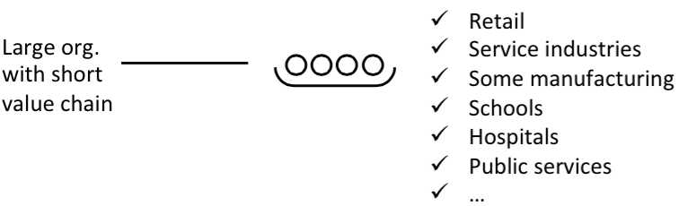

Web of individual contracting
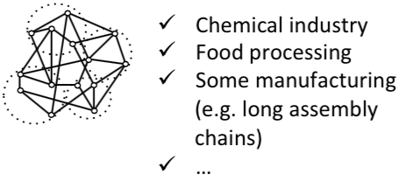

Nested teams (Circles)
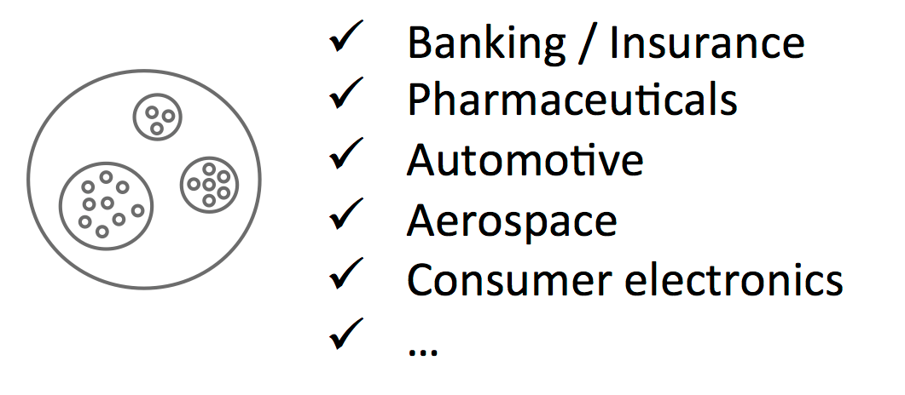

Frédéric Laloux, Reinventing Organizations
https://www.amazon.com/Reinventing-Organizations-Frederic-Laloux/dp/2960133501/
http://www.reinventingorganizationswiki.com/

Viable Systems Model

A viable system is any system organised in such a way as to meet the demands of surviving in a changing environment. One of the prime features of systems that survive is that they are adaptable. The VSM expresses a model for a viable system, which is an abstracted cybernetic (regulation theory) description that is applicable to any organisation.

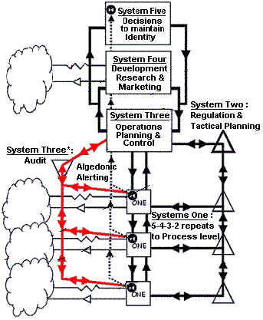

The model is too abstract to be directly useful. However, several key ideas stand out:

Viable systems are recursive; viable systems contain viable systems that can be modeled using an identical description as the higher (and lower) level systems in the hierarchy.

Some processes are done by many and often many processes are done by the same person. Throughout the working day a participant, in completing a task, may find the focus shifts between various systems from moment to moment.

The environment is represented in the model. The presence of the environment is necessary as the domain of action of the system and without it there is no way in the model to contextualize or ground the internal interactions of the organization.

https://en.wikipedia.org/wiki/Viable_system_model - Anthony Stafford Beer

